Q33. WAP to create a base class Student with private data-members as rollno, name, create a child class Marks that extends Student class with data members as marks in two subjects and then create a child class TotalMarks that extends Marks class which compute the total marks of a student and display all student details. Output should be like this:
Roll No is:
Name is:
Marks in First Subject:
Marks in Second Subject:
Total Marks:

class Student{
private int rollno;
private String name;

public void insert(int a, String b){
rollno = a;
name = b;
}
public void display(){
System.out.println(" Roll No is : "+rollno);
System.out.println(" Name is : "+name);
}

}
class Marks extends Student{
protected int m1;
protected int m2;

}
class TotalMarks extends Marks{
void InsertMarks(int a, int b){
m1 = a;
m2 = b;
}
public void disp(){
display();
System.out.println(" Marks in First Subject: : "+m1);
System.out.println(" Marks in Second Subject: : "+m2);
System.out.println(" Marks in Second Subject: : "+(m1+m2));
}

}
class abc{
static public void main(String args[]){
TotalMarks S1 = new TotalMarks();
S1.insert(1,"Shubham");
S1.InsertMarks(77,78);
System.out.println(" [ Shubham rawat ] \n [ MCA 2020 -2022 ]");
S1.disp();
}
}
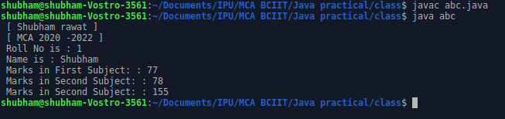

Q34. WAP to create a base class Employee with private data members as eid, ename, create a child class Programmer that extends base class Employee with data-members as experience, salary and create a child class Manager that extends class Employee with datamembers as specializaton, age. Display all the details by reading all the data from user. Output should be like this:
Emp id is:
Emp Name is:
Exp is:
Salary is:
Age is:
Specialization is:

import java.util.Scanner;
class Employee{

private int empid;
private String empname;

public void insert(int a,String b){
empid = a;
empname = b;

}
public void display(){
System.out.println(" Emp id is : " + empid);
System.out.println(" Emp name is : " + empname);

}

}

//Child class
class Programmer extends Employee{

int experience;
int salary;

public void insertRecord(int d,int f){

experience = d;
salary = f;
}
public void disp(){

display();
System.out.println(" Experience : "+experience+"\n Salary : "+salary);

}
}
class Manager{
String specializaton;
int age;
public void insertRecord(String d,int f){

specializaton = d;
age = f;
}
public void display(){
System.out.println(" Emp specializaton is : " + specializaton);
System.out.println(" Emp age is : " + age);

}
}

class inheritance{
static public void main(String args[]){
Programmer P1 = new Programmer();
Manager M1 = new Manager();
Scanner O = new Scanner(System.in);
System.out.println(" [ Shubham Rawat ] \n [ MCA 2020 - 2022 ]");

System.out.print("\n Enter Employee Id : ");
int q = O.nextInt();

System.out.print("\n Enter Employee Name : ");
String w = O.next();

System.out.print("\n Enter Employee experience : ");
int e = O.nextInt();

System.out.print("\n Enter Employee Salary : ");
int r = O.nextInt();

System.out.print("\n Enter Employee Specialization : ");
String a = O.next();

System.out.print("\n Enter Employee Age : ");
int s= O.nextInt();

P1.insert(q,w);
M1.insertRecord(a,s);
P1.insertRecord(e,r);
P1.disp();
M1.display();

}
}
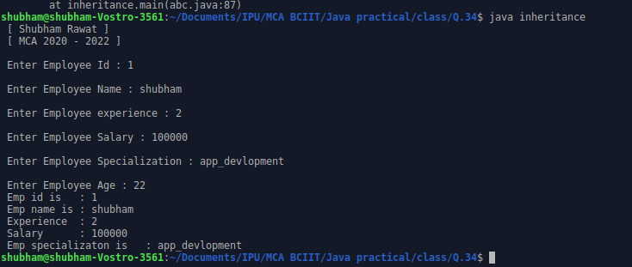

Q35. WAP to create a class Vehicle with method as run() -displaying the speed of vehicle and over-ride it in a child class Car.

class Vehicle{
public void run(){
System.out.println("Speed of Vehicle is 120 m/s ");

}
}

class Car{
void run(){
System.out.print("Speed of Car is 33.33 k/hr ");

}
}
class abc {
public static void main(String args[]){
Car C1 = new Car();
C1.run();
}
}
